МРНТИ

A. Askarova1 , Y. Gylymmedden2 , D.Temirbekova3 , N.Sultanova4

1,2,3,4 Suleyman Demirel University, Kaskelen, Kazakhstan

**SMM (Support medical machine)**

**Abstract.** Machine learning (ML) provides methods, techniques, and tools that can help solve diagnostic and prognostic problems in various fields of medicine. ML is used to analyze clinical parameters and their combinations for prognosis, such as disease progression, for maintenance therapy of treatment, and for General patient management. In our time, computer systems have already begun to be introduced into the healthcare environment, which makes it possible to facilitate and improve the efficiency of medical professionals and ultimately improve the efficiency and quality of medical care. Below is a demonstration to tell what the main applications of ML were used in the application and show how they can be useful for medical care. The main task was to combine all the useful functions that can help people in the field of medicine. The application will help to determine the authenticity of medicines through text recognition and search through the database of official drug registers, as well as using recommendation systems and algorithms (K-nearest neighbor Algorithm) to help in the selection of medicines, using the camera and phone flash to calculate the heart rate, which will accordingly help people with blood pressure problems. The application will be available on two platforms on iOS, as well as for the Android operating system, as it was implemented through the Flutter framework in Android Studio. For the algorithms, used Google's ML-Kit libraries. Jupyter, numpy, pandas, matplotlib, scipy, and scikit-learn Notepad are also used for data preparation.

**Keywords:** machine learning, KNN, medical, recommendation system, image recognition, Flutter, Android, IOS, heart rate.

**Аннотация.** Машинное обучение (МО) предоставляет методы, приемы и инструменты, которые могут помочь в решении диагностических и прогностических задач в различных областях медицины. МО используется для анализа клинических параметров и их комбинаций для прогноза, например прогрессирования заболевания, для поддерживающей терапии лечения, а также для общего ведение пациентов. В наше время уже начали вводить компьютерные системы в среду здравоохранения, что дает возможности облегчить и повысить эффективность работы медицинских специалистов и в конечном итоге повысить эффективность и качество медицинской помощи. Ниже хотим рассказать какие основные применения МО использовались в приложении и показать, как они могут быть полезны для медицинского обслуживания. Главной задачей было совместить все полезные функции, которые могут помочь людям в сфере медицины. Приложение поможет определить подлинность лекарств через распознавания текста и поиска по базе официальных регистров лекарств, а также с помощью рекомендательных систем и алгоритмов (Алгоритм K-ближайших соседей) помочь в выборе лекарств, с использованием камеры и вспышки телефона вычислить сердечный ритм, что соответственно поможет людям с проблемами давления. Приложение будет доступно на двух платформах на iOS, а также и для операционный системы Android, так как был реализован через фреймворк Flutter в Android Studio. Для алгоритмов мы использовали библиотеки Google’s ML-Kit. Также используется блокнот jupyter, numpy, pandas, matplotlib, scipy и scikit-learn для подготовки данных.

**Ключевые слова:** машинное обучение, KNN, медицина, рекомендательная система, распознавание изображений, флаттер, Андроид, IOS, частота сердцебиения.

**Aңдатпа.** Машиналық оқыту (MO) медицинаның әртүрлі салаларында диагностикалық және болжау мәселелерін шешуге көмектесетін әдістер, әдістер мен құралдарды ұсынады. МО клиникалық параметрлер мен олардың комбинацияларын болжау үшін, мысалы, аурудың өршуін, емдеудің демеуші терапиясын, сондай-ақ жалпы пациенттерді басқару үшін пайдаланылады. Қазіргі уақытта денсаулық сақтау ортасына компьютерлік жүйелер енгізіле бастады, бұл медицина мамандарының жұмысын жеңілдетуге және тиімділігін арттыруға, сайып келгенде медициналық көмектің тиімділігі мен сапасын арттыруға мүмкіндік береді. Төменде MO-ның негізгі қосымшалары қосымшада қандай қолданылғанын және олардың медициналық көмекке қалай пайдалы болатындығын көрсету көрсетілген. Негізгі міндет медицина саласындағы адамдарға көмектесетін барлық пайдалы функцияларды біріктіру болды. Қосымша дәрі-дәрмектердің түпнұсқалығын мәтінді тану және дәрі-дәрмектердің ресми регистрлеріне негізделген іздеу арқылы, сондай-ақ ұсыныс жүйелері мен алгоритмдер арқылы (K-жақын көршілердің алгоритмі) дәрі-дәрмектерді таңдауға, камера мен телефонның жарқылын қолдана отырып анықтауға көмектеседі.жүрек соғу жиілігін есептеңіз , бұл қысым проблемалары бар адамдарға көмектеседі. Қосымша iOS-тағы екі платформада, сондай-ақ Android операциялық жүйесі үшін қол жетімді болады, өйткені ол Android Studio-да Flutter шеңбері арқылы жүзеге асырылды. Алгоритмдер үшін біз Googleдің ML-Kit кітапханаларын қолдандық. Деректерді дайындау үшін jupyter, numpy, pandas, matplotlib, scipy және scikit-learn дәптері де қолданылады.

**Түйін сөздер**: машиналық оқыту, KNN, медицина, ұсыныс жүйесі, суретті тану, флаттер, Андроид, IOS, жүрек соғу жиілігі.

1. ***Introduction***

The smartphone in the 21st century is an integral part of many people's lives. Globally, there are about 2.6 billion smartphone subscriptions, and by 2020, this number is projected to reach 6.1 billion [1]. Smartphones with multimedia capabilities open new possibilities for app development and service delivery. Recently, smartphones have started to be used for medical purposes to measure numerous vital parameters such as heart rate (HR) and body temperature. This enables the use of a smartphone as a wireless HR monitor. At the moment, a huge part of society simply cannot imagine their life without this device. With the development of technology, smartphones can now become excellent assistants in the field of medicine.

SMM (Support Medical Machine) is a mobile app for home pharmacy inventory with an intelligent reminder system. It will help create reminders for taking medications in a matter of minutes, as well as help with the calculation of originality of the drugs, thanks to the KNN algorithm, it will help with the choice of medicines, based on individual characteristics of person. Travel will become easier if anyone have a global pharmacy locator in their pocket. Swiping finger across the camera lens activates scanning from the app, and after a few seconds, the user's heart rate will be detected and displayed.

1. ***Main part***

According to statistics and official data, in Kazakhstan, the share of counterfeit medicines accounts for more than 1%, in reality, this figure is certainly higher. Falsification has several types, as you can see, fakes can be both a good copy , as well as cause irreparable harm to health.

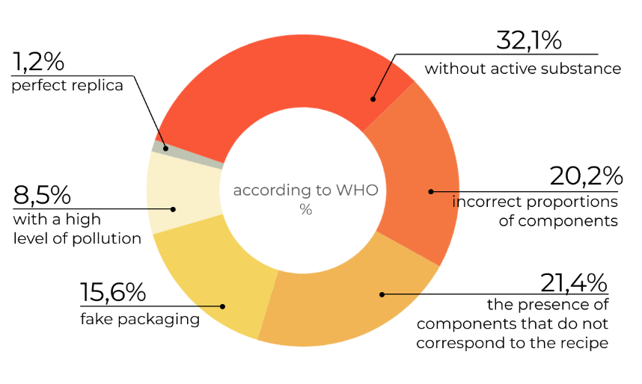

(Types of counterfeit medicines)

According to WHO statistics, the world's drug-related deaths are ranked fifth. The reason for this is poor-quality medicines. Thanks to the official database of the Ministry of the Republic of Kazakhstan, it is possible to solve this problem and check medicines by registration code and construct right recommendations system for drugs.

The app fully was developed on Flutter with Android Studio and Visual Studio 2019. Used such libraries like Dart SDK, Google ML-Kit. For design part used Figma.

Data.

To prepare data and implement algorithms, used Jupiter notebook with the pandas library,sklearn, etc. All data is in csv format. The data for authentication by text recognition was taken from the state open data portal egov (<https://data.egov.kz/datasets/view?index=gosudarstvenniy_reestr_lekarst>)

Data attributes:

1. name (text): name of the drugs
2. countryry(text): country of manufacture
3. regidru(text): registration number
4. recipru(categorical): recipe
5. id(numerical):id number
6. data(date): expiration date
7. atcclassificationru(text): classification of ATС
8. producerru(text): manufacturer
9. classificationru(text): the classification of drugs/medical devices
10. drugsformru(text): dosage form

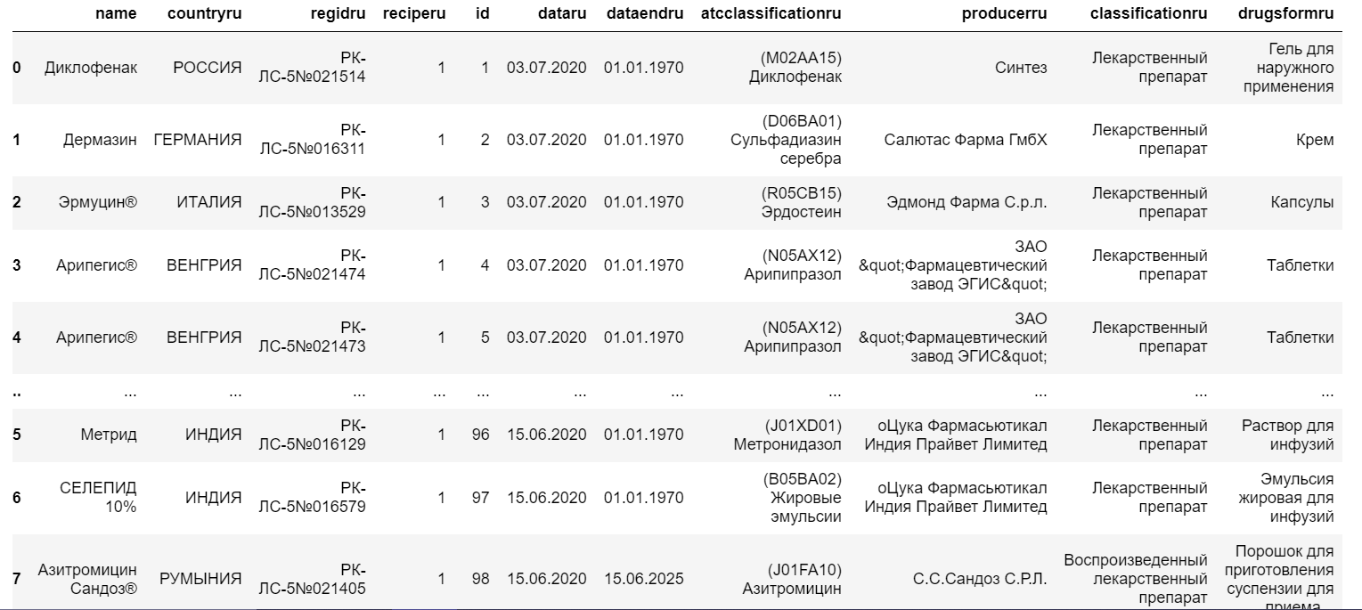

Data for recommendation is from <https://archive.ics.uci.edu/ml/datasets/Drug+Review+Dataset+%28Drugs.com%29>

The dataset provides patient reviews on specific drugs along with related conditions and a 10-star patient rating reflecting overall patient satisfaction. The data was obtained by crawling online pharmaceutical review sites.

Data Information:

1. drugName (categorical): name of drug

2. condition (categorical): name of condition

3. review (text): patient review

4. rating (numerical): 10-star patient rating

5. date (date): date of review entry

6. usefulCount (numerical): number of users who found review useful

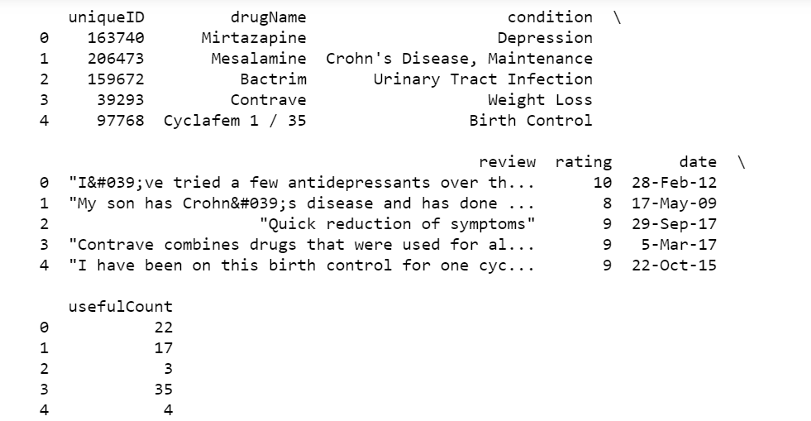

Text recognition:

To check the medicine for authenticity, click on the “Check” button, which opens gallery to select an existing photo. After selecting the desired photo, the program recognizes the text on the photo and finds the registration code, checks through our database of medicines and if it is in our database, then the medicine is original.

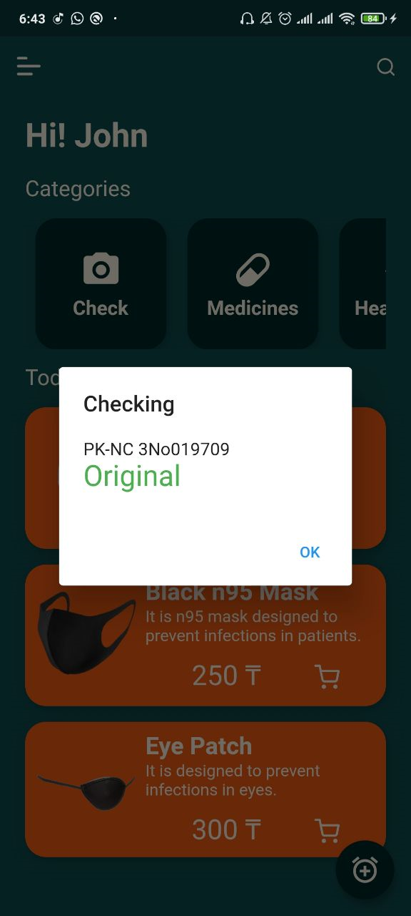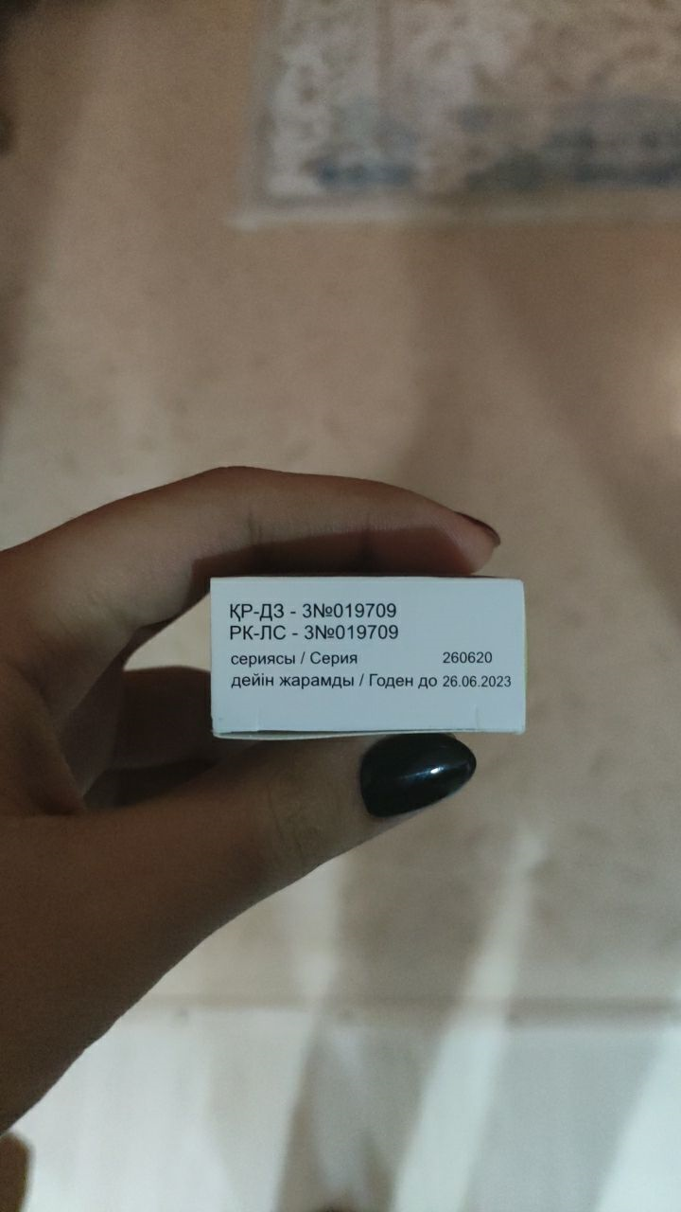

Registration codes are written in two languages, search in Russian works better because the Cyrillic alphabet is better recognized than the Kazakh alphabet.

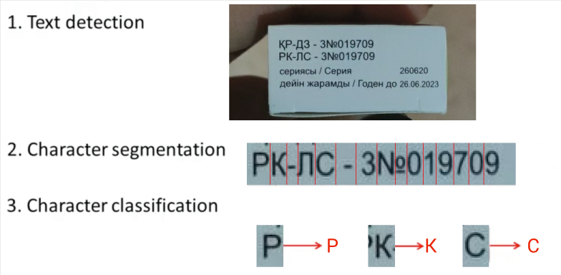

Accuracy of the recognized text depends on lots of factors including the quality of the photo, the angle of the text (such as less than 45 degrees of rotation deviated from the horizontal), lighting contrast and the resolution of the selected photo. For most cases, the recognition accuracy is quite good and acceptable though.

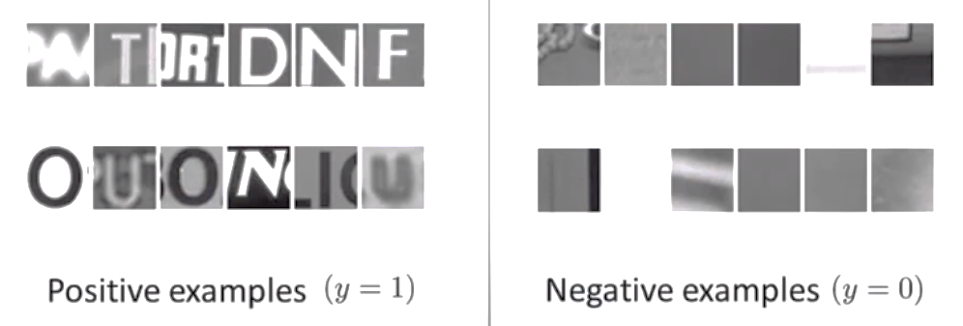

Positive examples (y = 1), patches with text

Negative examples (y = 0), patches without text

For implementation, used the simple OCR plugin by Google's ML-Kit library.

Analog system:

For the analog or recommendation system, the KNN algorithm is used. The main parameters are DrugName (the name of the drug), condition (purpose of the drug), usefulcount (number of times when the drug helped).

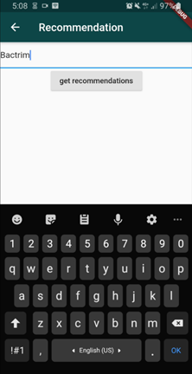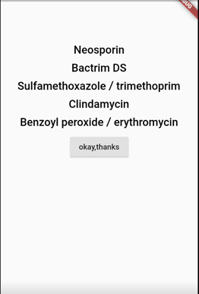The algorithm searches for the nearest neighbors by these parameters and outputs the 5 closest ones. Possible drug alternatives are displayed.

The ready-made recommendations that code brought out were placed in a separate file. From the localhost the request with the name of the drug is accepted, then search for it in the file and output recommendations. Flutter sends a request to the local host with the name of the medicine that the user entered and accepts recommendation data from the local host and displays it on the screen.

Heart rate system:

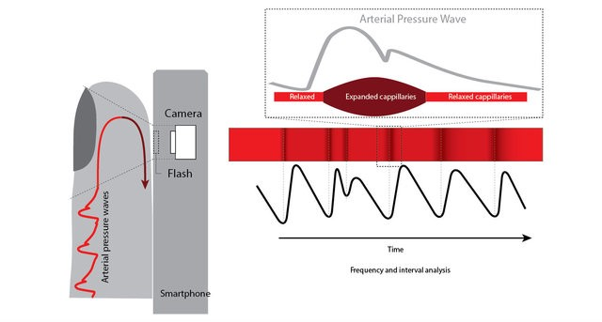Shining a light into a blood irrigated tissue, help to measure the variability of reflected light and extract the variation of blood flow. As we all know, the blood flow is dependent on the heart rate, so to calculate the heart rate using the blood flow variation.

(Vandenberk, et. al. (2017). Clinical Validation of Heart Rate Apps: Mixed-Methods Evaluation Study. JMIR Mhealth Uhealth. 5. e129. 10.2196/mhealth.7254.)

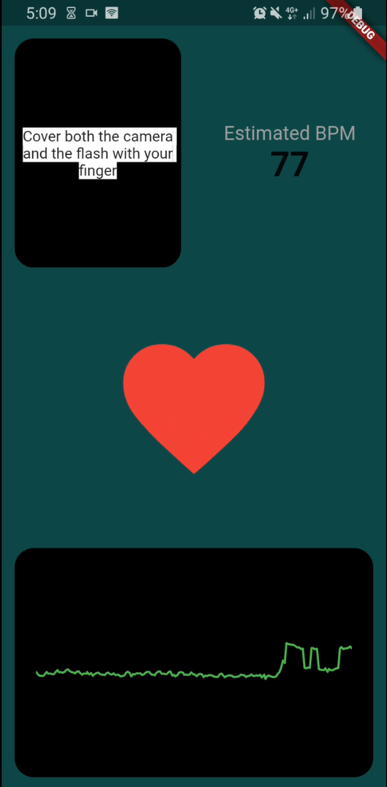In application need shine the camera’s flash and the app measure the intensity reflected using the phone’s camera. More specifically, the app will measure the average value of all the pixel’s intensity of the camera image. Then, if cover the camera and flash with finger, the intensity measured will vary with the blood flow.

1. ***Conclusion***

In conclusion as a result of the analysis of the market for the sale of counterfeit medicines in Kazakhstan, an increase in sales and production of illegal medicines was found during the global pandemic. to solve this problem, we have compiled a task in the development of an application that works on the basis of machine learning and which would help in the selection of drugs, authentication and calculation of heart rate. The best option in choosing the means to achieve this goal was decided to write a project on Flutter, thereby increasing our target audience of consumers, since with the help of this framework, the application will be available for both iOS and android users. Thus, it will reduce the risks of poisoning and mortality from low-quality drugs.

In the initial plans, the task was to make a universal application with a built-in drug store, with a system for finding the nearest pharmacies and a smart reminder system with the above-mentioned functions. Our time was limited and we focused on the main idea, the implementation of machine learning algorithms in real life.

Our tool will be very useful for users, data may not be completely accurate and for a complete analysis and diagnosis, we still recommend contacting a doctor. To take a drug from the recommendation system, it is better to consult a doctor in cases of personal intolerance, etc. In the future, it will be possible to use the app for medical staff and simplify the task of tracking the state of heart rate and heart jumps. The app will be able to record each time the heartbeat and all the jumps, which will help in identifying diseases such as arrhythmia, tachycardia and other heart diseases. The weakness of our program is the lack of data from the drug registry and the lack of fake drugs to identify authenticity. At the moment, the data is limited to 100 units of information about medicines. With the development of the app, I would like to add the function of full tracking of medication intake and expiration date with a reminder. This application has a great potential for development both in cases of individual use and for doctors to track and monitor patients ' medication intake. With the development of technology and gadgets such as smart watches and bracelets, by connecting these gadgets with the application to analyze the General condition in non-stop mode and in the event of cardiac arrest or General deterioration of health, notify the user, the doctor and in critical situations the possibility of an automatic call to the rescue service, which could prevent deaths and help to call for help in time. Initially, the main task was to help the older generation in tracking their own health and tracking the state of their loved ones. But in such a difficult time, everyone needs to monitor their own health and the problem in the health sector will always be relevant.

**Literature review**

Background: The purpose of this literature review is to compare different methods and identify the most optimal ones for application development. Mobile phone apps that can track arrhythmias and heart rate (HR) are increasingly being used for screening, diagnosing, and monitoring your heart rate. These applications include either the use of photoplethysmographic recording or a portable external electrocardiographic recording device attached to a mobile phone or wristband. This review aims to examine the current state of mobile phone applications in cardiology, as well as identify shortcomings for further research.

Method: We conducted a descriptive review of mobile phone usage by searching PubMed and EMBASE from their inception until October 2018. The potentially relevant articles were then compared to the checklist for relevance and considered independently for inclusion, focusing on 4 highlighted topics: mobile phone monitoring, heart rate, and heart rate variability (HRV).

Results: The results of these studies revealed that in the first study, heart rate (HR, beats per minute) 88 random subjects, consistently measured with 3 instruments showed a correlation coefficient 0,834 between fibroscan and nanina, of 0.88 between FIBROSCAN and olivetorum and 0,897 between nananom and olivetorum. To test the hypothesis that there were no significant differences between the heart rate measured by 3 devices, a single-factor analysis of variance (ANOVA; P=.61) was performed. the second study analyzed 20,298 (MS) r-r intervals (RRI)-Peak-to-peak intervals (PPI) from 229 subjects. This resulted in a positive correlation (rs=.993, mean square deviation [RMSE]=23.04 MS and normalized mean square error [NRMSE]=0.012) between the PPI from FibriCheck and the RRI from the wearable ECG. There was no significant difference between these intervals (P=0.92). And using this data we can say that the results of the measurement through the camera and through the FibriCheck are quite similar

Conclusions: a number of studies have demonstrated the high accuracy of a number of different mobile devices for heart rate monitoring. However, further research is needed to confirm their use for large-scale screening and detection of heart abnormalities. After conducting an analysis, it can be stated that it is acceptable and affordable for a wide audience to use only one camera to calculate the heart rate . After reviewing the research results and comparing the technologies, we came to the conclusion that the most appropriate method for validating the HR application is to simultaneously measure the heart rate using a smartphone application and an ECG system, compared based on a heartbeat analysis. This approach can lead to more accurate estimates of the accuracy of HR applications.

**References**

1. Duda R, Hart P, Stork D: Pattern Classification. 2nd edition. New York, NY: John Wiley & Sons, Inc.; 2001.
2. Mitchel T: Machine Learning. New York NY: McGraw Hill; 1997.
3. Application Example Photo OCR, Lecture 18.2 Andrew Ng. Сoursera;2019.
4. Vandenberk, et. al. (2017). Clinical Validation of Heart Rate Apps: Mixed-Methods Evaluation Study. JMIR Mhealth Uhealth.